2026 TECH MAHINDRA TEST-4

Test Summary

* No. of Sections: 3
* No. of Questions: 47
* Total Duration: 90 min

Section 1 - VERBAL

Section Summary

* No. of Questions: 20
* Duration: 20 min

Additional Instructions:

None

Q1.

A sentence is given with five words highlighted and marked as (A), (B), (C), (D) and (E). Choose the option with the pair(s) of words that need to be interchanged to make the sentence grammatically and contextually correct.

He was **down (A)** on the grass till the **totally (B)** ran over **him (C)**, and the flies **settled (D)** on his nose while he was **beetles (E)** ill till late in the night.

A-D

B-E

C-B

No change required

Q2.

**Fill in the blank using the appropriate answer option :**

Using language that equates disability to do something ______ can be problematic in several ways.

depression

optimistic

favorable

negative

Q3.

**From the options given below, select the option that states the incorrect set of sentences.**

A. Standing about 10 inches tall, the shy animal once roamed the border regions of India, Nepal, and Bhutan.

B. When I got involved in this project, I realized this could give me the purpose that I have been searching for my entire death.

C. But the story doesn't end there, because the novel science that we will do for this mission will benefit all of humanity.

A only

B only

A and C

B and C

None of the mentioned options

Q4.

**Complete the following sentence by choosing the right option.**

Barbara, your boyfriend is waiting for you **.......** in the car.

around

outside

above

against

Q5.

Select the most suitable synonym:

**Detest**

Argue

Hate

Discover

Reveal

Q6.

**Complete the following sentence by choosing the right option.**

The second hotel was different ____ the first.

to

for

with

from

Q7.

**Choose the word that is most nearly opposite in meaning to the given words.**

EXTEMPORANEOUS:

captious

impeccable

auspicious

rehearsal

None of the mentioned options

Q8.

**Substitute the given sentences with one word.**

One who offers one’s services,

Fracas

Lament

Volunteer

Grogram

Q9.

Each question has a number of sentences which, when properly sequenced, form a coherent paragraph. Each sentence is labeled with a letter. Choose the most suitable order of sentences from among the four given choices to construct a coherent paragraph.

A. On the other hand a workable machinery to keep vigil at and preserve the purity and character of places and monuments will do some good to Gods own country

B. More and more hotels and lodges, restaurants, health clinics and shops have so sprung up in and around resorts that the natural bounty of the regions is going at a discount

C. However, the Kerala tourism ministers idea of making the tourist sites/resorts affordable only to the “rich” completely ignoring the less privileged classes is not correct

D. Kerala, in recent years, has attracted hordes of tourists necessitating growth of infrastructure, which has upset the aesthetic beauty and environment of resorts like Munnar, Thekkady and Kumararkom

BCAD

DBCA

DCBA

BADC

Q10.

Read each sentence to find out whether there is any error in it. The error, if any, will be in one part of the sentence. The number of that part is the answer.

If I was the Prime Minister .1/ I would resolve .2/ this issue .3/ within no time.4

1

2

3

4

Q11.

Read each sentence to find out whether there is any error in it. The error, if any, will be in one part of the sentence. The number of that part is the answer.

(1) The hare thought / (2) that it could / (3) run enough fast to / (4) overtake the tortoise easily. / (5) No error

1

2

3

4

Q12.

Choose the meaning of the underlined idioms.

I cannot understand why she did that, it really doesn't add up.

doesn't calculate

isn't mathematics

doesn't make sense

makes the wrong additionmakes the wrong addition

Q13.

Choose the meaning of the underlined idioms.

He has sold his house and has no job and so now he has next to nothing.

he is unemployed

he has almost no money

he has a few things

he has nothing at all

Q14.

Read each sentence to find out whether there is any error in it. The error, if any, will be in one part of the sentence. The number of that part is the answer.

Alas! 1./ How lovely 2./ and fragrant 3./ these flowers are! 4./

1

2

3

4

Q15.

Each question has a number of sentences which, when properly sequenced, form a coherent paragraph. Each sentence is labeled with a letter. Choose the most suitable order of sentences from among the four given choices to construct a coherent paragraph.

A. As such the statue of Apollo which stood astride the entrance of the Agean port of Rhodes , fell neatly into the definition

B. In ancient times any statue which was larger than life size was called a colossus

C. That statue was said to have been 71 cubic high or just under 107 feet

D. It was a colossus

ABCD

BADC

BCDA

CBAD

Q16.

Read each sentence to find out whether there is any error in it. The error, if any, will be in one part of the sentence. The number of that part is the answer.

He did not come to the office .1/ as he felt ill .2/ of the way .3/ his manager treated him.4

1

2

3

4

Q17.

Find the synonym of the given word:

ABANDON :

Forsake

Keep

Cherish

Enlarge

Q18.

Each question has a number of sentences which, when properly sequenced, form a coherent paragraph. Each sentence is labeled with a letter. Choose the most suitable order of sentences from among the four given choices to construct a coherent paragraph.

A. In this frame work the World Tourism Organisation and the United Nations Environment Programme organized a pioneering forum earlier this year that was conducted solely online

B. Over the past two decades, ecotourism activities have expanded rapidly and further growth is expected in the future

C. Recognising its global importance, the united nations designated the year 2002 as the international year of Ecotourism, and its Commission on sustainable development and the private sector to undertake supportive activities

D. The prime objective was to provide easy access for a wide range of stakeholders involved in ecotourism to exchange experiences and voice comments

BCAD

CDAB

DCBA

ABDC

Q19.

Find the synonym of the given word

MASSIVE:

Lump sum

Strong

Little

Gaping

Huge

Q20.

Read each sentence to find out whether there is any error in it. The error, if any, will be in one part of the sentence. The number of that part is the answer.

It is .1/ no use .2/ to argue .3/ with him.4

1

2

3

4

Section 2 - Q&R

Section Summary

* No. of Questions: 15
* Duration: 20 min

Additional Instructions:

None

Q1.

A and B working separately can finish a work in 12 and 18 days respectively. If they work together for 5 days and then A goes away, in how many days will B complete the work?

5 days

6.5 days

6 days

5.5 days

Q2.

D is the brother of B. M is the brother of B. K is the father of M. T is the wife of K. How is B related to T?

Son

Daughter

Son or Daughter

Data inadequate

Q3.

DKY, FJW, HIU, JHS, ?

KGR

LFQ

KFR

LGQ

Q4.

How many cubes of 4 cm side can be formed from a cube of 16 cm side?

27

64

216

125

Q5.

Find the angle between the hour hand and the minute hand of a clock when the time is 3.25.

74 1/2°

45 1/2°

49 1/2°

47 1/2°

Q6.

In each of the following questions, there are four figures (i), (ii), (iii) and (iv) which constitute the problem set and answer figures marked 1, 2, 3, 4 each consisting of two figures marked (i) and (iv) which constitute the answer set. Select figure from the answer sets the contents of which best substitute (?) in the problem set such that figure (iii) is related to figure (iv) in same way as figure (i) is related to figure (ii).

Q7.

In the following questions the first and the last blocks mark the beginning and the end of a series respectively. The numbered blocks are a part of the series. However, one of these numbered blocks violates the pattern. Find the odd block and mark your answer.

2

3

4

5

Q8.

A school has 30% students from Rajasthan. Out of these, 20% are Jaipur students. Find the total percentage of students from Jaipur?

9%

10%

4%

6%

Q9.

Kareena travels 5 km straight followed by 12 km towards her right. What is the distance between the starting and the final position of Kareena?

13 km

17 km

7 km

11 km

Q10.

The simple interest on a certain sum of money at 4% per annum for 4 yrs is Rs. 80 more than the interest on the same sum for 3 yrs at 5% per annum. Find the sum.

Rs. 6000

Rs. 7000

Rs. 9000

Rs. 8000

Q11.

A man sells an article at a loss of 20%. Had he bought it 20% less and sold it for Rs. 60 more, he could have gained 50%. What is the cost price of the article?

Rs.150

Rs.100

Rs.200

Rs.120

Q12.

At what time between 2 and 3 o’clock will the hands of a clock be together?

10 10/11 past 2

10 15/11 past 2

15 10/11 past 2

15 15/11 past 2

Q13.

If 1st Jan 2000 was Sunday, then in which year again (for the first time) will 1 January be a Sunday?

2004

2002

2005

2007

Q14.

ABCD is a square .E is appointed on AB such that BE = 17 cm.The area of triangle ADE is 84 cm2.What is the area of square?

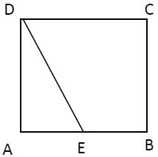

400 cm2

625 cm2

729 cm2

576 cm2

Q15.

Statements- Some goats are cows.

Some cows are fowls.

Conclusions-

I. Some goats are fowls.

II. No goat is fowl.

If only the conclusion I is true.

If only the conclusion II is true.

If either conclusion I or the conclusion II is true.

 When neither the conclusion I nor II is true.

Section 3 - TECHNICAL

Section Summary

* No. of Questions: 12
* Duration: 50 min

Additional Instructions:

None

Q1.

Choose the correct query using the IFNULL function of SQL to replace the NULL value in the experience column of DataFlair with 0.

Select * From DataFlair IFNULL(experience) = 0;

SELECT name, IFNULL(experience, 0) AS experience

FROM DataFlair;

All of the mentioned options

None of the mentioned options

Q2.

The overflow property in CSS can take one of the following values.

i) visible

ii) hidden

iii) scroll

iv) non-scroll

v) auto

i, ii, iii and iv only

i, ii, iii and v only

i, ii, iv and v only

i, ii, iii, iv and v

Q3.

Which class/set of classes can illustrate polymorphism in the following code snippet?

Only class student can show polymorphism

Only class student and topper together can show polymorphism

All class student, topper and average together can show polymorphism

Class failed should also inherit class student for this code to work for polymorphism

Q4.

What will be the output for the following code?

Garbage Value

10

5

0

Q5.

In the case of abstract class or function overloading, which function is supposed to be called first?

Local function

Function with highest priority in compiler

Global function

Function with lowest priority because it might have been halted since long time, because of low priority

Q6.

What will be the output of the following code snippet?

111

123

321

121

Q7.

Which is a valid constructor of this class?

public TennisBall static create()

{

return

new TennisBall();

}

public TennisBall static newInstance()

{

return

new TennisBall():

}

public TennisBall() {

}

None of the mentioned options

Q8.

Predict the output of the following code:

abcde

6566676869

Compile Time Error

[I@some_hashcode

Q9.

The Boolean expression A'.B + A.B' + A.B is equivalent to

A + B

A'.B

(A + B)'

A . B

Q10.

Study the given flow chart and answer the question.

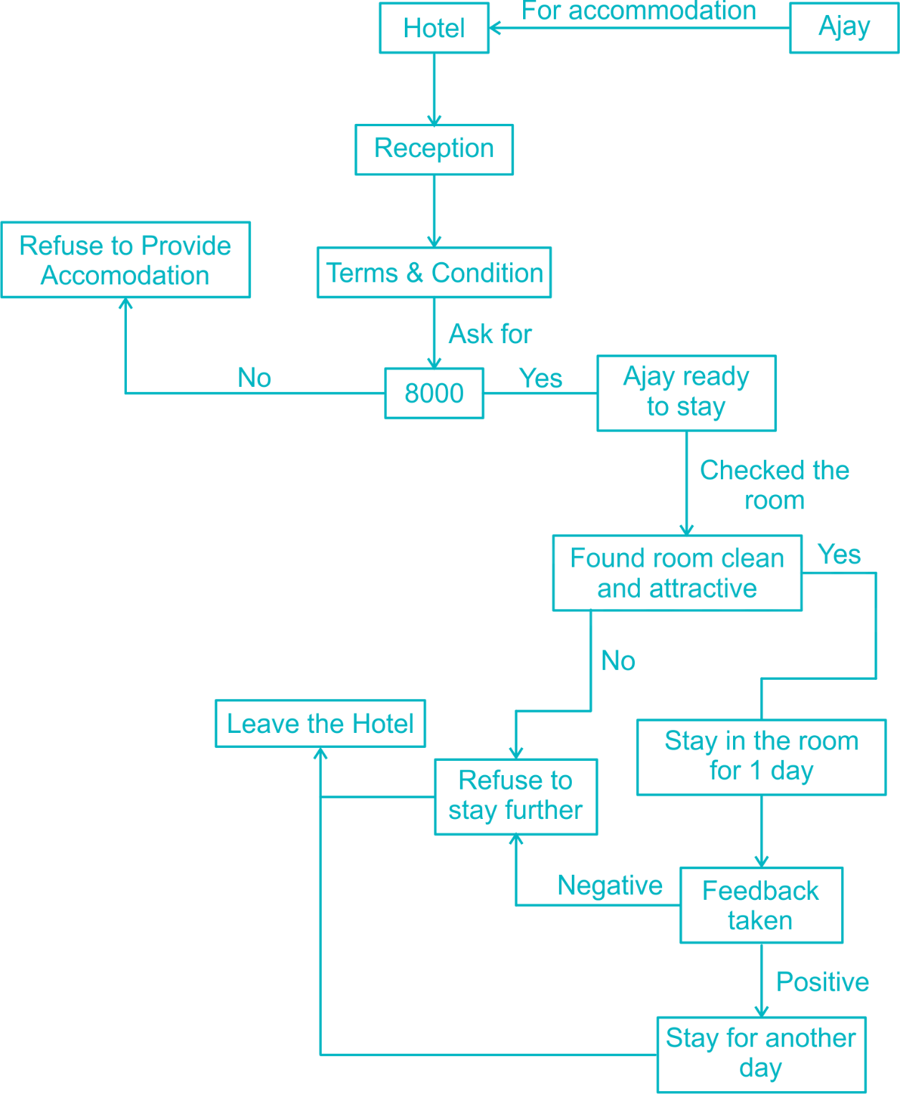

A tourist Ajay wants to stay in a hotel. So, different conditions are given in the data flow diagram. So after analyzing the above DFD diagram you have to answer the given questions

Which Condition is sufficient to make sure that Ajay will not stay further?

(a) If he submits six thousand rupees in the reception.

(b) If the feedback which is given by him is negative.

(c) If required pub facility is not available in the hotel.

Both (b) and (c)

Q11.

**Problem Statement**

Ben is studying matrices and wants to write a program that swaps two rows of a matrix (N, M), the program takes an input matrix, swaps the specified rows, and then displays the modified matrix.

Assist him with the program.

Input Format

The first line consists of two space-separated integers **N** and **M**, representing the number of rows and columns in the matrix.

The next **N** lines contain **M** space-separated integers each, representing the elements of the matrix.

The last line consists of two space-separated integers **r1** and **r2**, representing the row numbers to be interchanged.

Output Format

If the input row numbers r1 or r2 are invalid (less than 1 or greater than the number of rows), the output prints "Invalid row numbers".

Otherwise, the modified matrix is printed after swapping the specified rows.

**Refer to the sample output for the formatting specifications.**

Constraints

In this scenario, the test cases will fall under the following constraints:

2 ≤ N, M ≤ 10

r1, r2 ≤ N

1 ≤ Each element ≤ 100

Sample Input

3 3

11 12 13

42 53 67

75 87 99

2 1

Sample Output

42 53 67

11 12 13

75 87 99

Sample Input

4 3

1 4 6

2 3 5

6 4 2

8 9 2

2 5

Sample Output

Invalid row numbers

Sample Input

9 10

79 8 52 69 70 5 61 62 68 77

56 43 18 89 3 12 66 35 91 47

76 27 28 14 59 98 92 6 13 30

96 73 65 17 58 72 24 90 64 82

81 60 55 4 42 78 26 63 21 97

93 40 54 83 94 1 100 25 99 2

37 16 84 49 23 57 75 34 67 41

32 46 50 88 31 53 86 48 95 38

9 11 33 7 22 44 15 51 45 80

3 5

Sample Output

79 8 52 69 70 5 61 62 68 77

56 43 18 89 3 12 66 35 91 47

81 60 55 4 42 78 26 63 21 97

96 73 65 17 58 72 24 90 64 82

76 27 28 14 59 98 92 6 13 30

93 40 54 83 94 1 100 25 99 2

37 16 84 49 23 57 75 34 67 41

32 46 50 88 31 53 86 48 95 38

9 11 33 7 22 44 15 51 45 80

Sample Input

2 3

1 4 5

5 6 8

2 1

Sample Output

5 6 8

1 4 5

Time Limit: - ms Memory Limit: - kb Code Size: - kb

Q12.

**Problem Statement**

The task is to print a pyramid pattern of numbers with n rows, where each row i contains the number i repeated i times. The pyramid should be aligned such that the numbers in each row are centered, creating a symmetric structure. After the pyramid is printed, calculate the sum of all the numbers that have been printed and display the sum in the following format: "Sum of all numbers: <sum>".

Input Format

The input consists of a single integer n, where n represents the number of rows in the pyramid.

Output Format

The output consists of the following the Pyramid Structure

* The pyramid will be printed with n rows.
* Each row i will contain the number i repeated i times.
* Each number in a row will be separated by a space, and the rows will be aligned to form the pyramid shape.
* The rows will be aligned such that the first row is centered and subsequent rows follow the alignment.

After the pyramid is printed, the sum of all the numbers in the pyramid should be calculated and printed in the following format:

**Sum of all numbers: <sum>**

**Refer to the sample output for formatting specifications.**

Constraints

1 ≤ n ≤ 100

1 ≤ i ≤ n

Sample Input

7

Sample Output

1

2 2

3 3 3

4 4 4 4

5 5 5 5 5

6 6 6 6 6 6

7 7 7 7 7 7 7

Sum of all numbers: 140

Sample Input

8

Sample Output

1

2 2

3 3 3

4 4 4 4

5 5 5 5 5

6 6 6 6 6 6

7 7 7 7 7 7 7

8 8 8 8 8 8 8 8

Sum of all numbers: 204

Time Limit: - ms Memory Limit: - kb Code Size: - kb

Answer Key & Solution

Section 1 - VERBAL

Q1

B-E

Solution

The word 'B' is an adverb, but it is preceded by the definite artilce 'the' suggesting the placement of a noun after the article.

The word 'E' at its position does not convey a logical meaning as to how can a person make beetles ill by laying down on the grass.

Thus, 'B' and 'E' must be swapped.

Q2

negative

Solution

An adjective would fit in the blank to describe the attribute associated with the noun 'disability'.

'Depression' is a noun.So it is eliminated.

'Optimistic' and 'favorable' are adjectives but are contextually unfit because when disability is equated to something unpleasant only then it can be a problem.

'Negative' is an adjective and is suitable for this blank

Q3

B only

Solution

Checking the sentences, we have

Sentence (A) - This sentence has no errors.

Sentence (B) - The sentence talks about a person searching for a purpose and so the usage of word 'death' is contextually incorrect and must be replaced with the word 'life' (searching for purpose throughout the course of life)

Sentence (C) - This sentence has no errors.

Hence, Only B has error

Q4

outside

Solution

No Solution

Q5

Hate

Solution

to detest means to feel intense or violent dislike, or to hate

Q6

from

Solution

No Solution

Q7

rehearsal

Solution

Extemporaneous means Carried out or performed with little or no preparation; impromptu, whereas rehearsed means practised a few times for later.

Q8

Volunteer

Solution

No Solution

Q9

DBCA

Solution

None of the statements except D can begin the paragraph because they cannot make complete sense unless preceded by a previous statement. B is a continuation of what is mentioned in D, so it should come immediately after D. So the answer is 2.

Q10

1

Solution

Ans (1). Replace ‘was’ by ‘were’. The question given here is hypothetical and I will never be that person I am telling (an imaginary condition). So it should take the second person to create the subjunctive mood. As a second person here, he takes the verb ‘were’. This sentence is of conditional clause type II and in this type ‘were’ replaces ‘was’ though the pronoun is I/ he/ she/it. Hence the part to be corrected is 1.

Q11

3

Solution

The error is in 3rd part of the sentence. ‘Enough’ is used as an interjection in this context (like ready enough). ‘Fast’ is an adverb that describes the verb ‘run’ and it should be placed after the verb (action). ‘Run fast enough’ is structurally correct

Q12

doesn't make sense

Solution

"Add up" means make sense. So doesn't add up means does not make sense.

Q13

he has almost no money

Solution

If you have next to nothing, it usually refers to having hardly any money/financial support.

Q14

1

Solution

Ans (1). ‘Alas’ is an interjection used to express grief or pity. The sentence expresses surprise pleasure. The apt interjection to be used here is ‘Wow’. Hence erroneous part is 1.

Q15

BADC

Solution

‘As such’ in A and ‘that statue’ in C tell us that the statements are referring to a previous one. Hence A and C are ruled out as the opening sentences. B followed by C (as in c) cannot be the choice as the word “that statue” in C doesn’t refer to B, but to ‘a colossus’ of D. hence the choice is B followed by A as in (b)

Q16

2

Solution

Fell ill is the right phrase and not felt ill

Q17

Forsake

Solution

Keep : have or retain possession of.

Cherish : protect and care for (someone) lovingly.

Enlarge : make or become larger or more extensive.

Forsake : abandon or leave.

Abandon : cease to support or look after (someone), desert.

Q18

BCAD

Solution

The words ‘this’ and ‘its’ in A and C respectively and the definite article ‘the’ before ‘prime objective’ in D undoubtedly indicate that the sentences can not survive independently. Hence the obvious choice is B as the first sentence.

Q19

Huge

Solution

Lump sum : a single payment made at a particular time, as opposed to a number of smaller payments or installments.

Strong : having the power to move heavy weights or perform other physically demanding tasks.

Little : small in size, amount, or degree.

Gaping : wide open.

Huge : extremely large; enormous.

Massive : exceptionally large.

Q20

3

Solution

Ans (3). Error is in part 3. The correct sentence is ‘It is no use in arguing with him’. In the sentence ‘to argue’ is infinitive. In general, the gerund must be used when a verb comes after a preposition and it acts as an object. So it should be ‘in arguing’.

Section 2 - Q&R

Q1

5.5 days

Solution

A = 12 = 3

B = 18 = 2

Total work = 36 units

A + B working for 5 days and completes 25 units

Remaining 11 units is completed by B

Time = 11/2 = 5.5 days

Q2

Son or Daughter

Since gender of B is not known. B can either be son or daughter of T

Q3

LGQ

Solution

The given series is DKY, FJW, HIU, JHS

The first letter of each set is the first letter of the previous set + 2

F = D + 2, H = F + 2, J = H + 2

So the next set first letter will be J + 2 = L

The second letter of each set reduces by 1 in each case

i.e. K, J, I, H

So in the next set it should be G

The third letter of each reduces by 2 in each case

Y - 2 = W, W - 2 = U, U - 2 = S

So the next letter should be S - 2 = Q

The next word should be LGQ

Q4

64

Solution

Each side of 16 cm can be cut into 16*4 = 4 to make 4 cm side smaller cubes.

Volume of Larger cubes = n x Volume of Smaller cubes

16 x 16 x 16 = n x 4 x 4 x 4

Therefore, total no. of 4 cm cubes = 43 = 64

Q5

47 1/2°

Solution

Speed of the Hour hand = 0.50/min

Speed of the Minute hand = 60 /min

Angle traced by Minute hand in 25 min = 1500 (25 x 60)

Angle traced by Hour hand in 3 hrs and 25 min ( 205 min) = 102.50

Angle between Hour hand and minute hand = 1500 - 102.50 = 47.50

Q6

Solution

 Both the figures interchange positions.

Q7

5

Solution

The curved line shading moves one step anti-clockwise and the dark shading moves one step clockwise in, each turn. So, the dark shading in figure (5) should have been two step up.

Q8

6%

Solution

Let the No. of students in a school = x

No of Students from Rajasthan = (30/100) × x = 0.3x

No of Students from Jaipur = (20/100) × 0.3x = 0.06x

% of Students in School from Jaipur = (0.06x / x) × 100 = 6 %

ans option 4

Q9

13 km

Solution

The path traversed by Kareena is as follows.

AB= √((OA)2 + (OB)2)

OA = 5 km, OB = 12 km

AB = √((5)2 + (12)2) = √(25 + 144) = √(169) = 13 km.

Q10

Rs. 8000

Solution

S.I1 = 16% of P

S.I2 = 15% of P

Difference = 1% of P= 80

100% = 8000

Q11

Rs.150

Solution

Let the cost price of the article, C.P 1 = Rs. X.

We know that,⇒ Selling Price = Cost price × (1 ± Profit or loss %)

Earlier the article was sold at a loss of 20% thus its selling price

(50/100)*0.8 X=60

⇒ X = Rs. 150

Hence, the cost price of the article is Rs. 150.

Q12

10 10/11 past 2

Solution

At 2 o’ clock, the hour hand is at 2 and the minute hand is at 12, i.e. they are 10 min. spaces apart.

To be together, the minute hand must gain 10 minutes over the hour hand. Now, 55 minutes are gained by it in 60 min.

10 minutes will be gained in (60/55) x 10 min = 10 10/11 min

The hands will coincide at past 2.

Q13

2005

Solution

1 Jan 2000 - Sunday

Next time first January will again be Sunday if there is one odd day for that (assuming the base date as 1 Jan 2000 to be Sunday).

Total odd days 7 + 1 (1 odd of 1st Jan of particular year). So 1st Jan 2005 would be Sunday.

Q14

576 cm2

Solution

Let each side of the square be a, then

AE = AB - BE = (a-17)

Area of triangle = 1/2 (AD x AE) =1/2 (a) (a-17) = 84

a2 - 17a - 168 =0

a = 24

Area of square = (24)2 =576 cm2.

Q15

If either conclusion I or the conclusion II is true.

Solution

Both the given statements are particular propositions. So no logical conclusion can follow from them by deductive method. The reason is that the middle term is not distributed in the particular premise though its distribution is an essential condition for a valid conclusion.

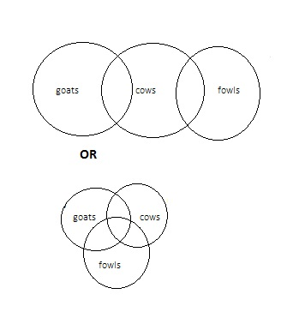

Either I or II follows.

Section 3 - TECHNICAL

Q1

SELECT name, IFNULL(experience, 0) AS experience

FROM DataFlair;

Solution

No Solution

Q2

i, ii, iii and v only

Solution

No Solution

Q3

All class student, topper and average together can show polymorphism

Solution

Explanation: Since Student class is abstract class and class topper and average are inheriting student, class topper and average must define the function named calc_grade(); in abstract class. Since both the definition are different in those classes, calc_grade() will work in different way for same input from different objects. Hence it shows polymorphism.

Q4

0

Solution

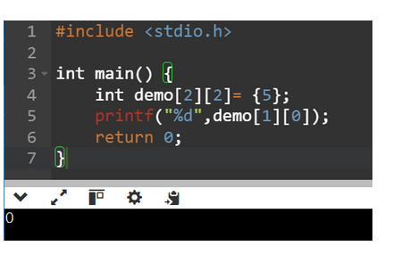

Q5

Function with highest priority in compiler

Solution

The member function with the highest priority is called first when there is function overloading, or abstract class is used.

Q6

123

Solution

No Solution

Q7

public TennisBall() {

}

Solution

No Solution

Q8

[I@some_hashcode

Solution

No Solution

Q9

A + B

Solution

= A'.B + A.B' + A.B

= A'.B + A.B + A.B'

= B(A' + A) + A.B'

= B + A.B'

= (B+A).(B+B')

= A+B

Q10

(b) If the feedback which is given by him is negative.

Solution

If Ajay submits 6,000 rupees , then accommodation is Refused so option (1) does not follow And in DFD nowhere mention about the details of pub facility. so we cannot consider option (3) , But option (2) shows Ajay will not stay further.

Q11

Solution

#include <stdio.h>

int main() {

int rows, columns;

scanf("%d %d", &rows, &columns);

int i, j, arr[10][10];

for (i = 0; i < rows; ++i) {

for (j = 0; j < columns; ++j) {

scanf("%d", &arr[i][j]);

}

}

int r1, r2, temp;

scanf("%d %d", &r1, &r2);

if (r1 < 1 || r1 > rows || r2 < 1 || r2 > rows) {

printf("Invalid row numbers");

} else {

// Swap elements in both rows

for (j = 0; j < columns; ++j) {

temp = arr[r1 - 1][j];

arr[r1 - 1][j] = arr[r2 - 1][j];

arr[r2 - 1][j] = temp;

}

for (i = 0; i < rows; ++i) {

for (j = 0; j < columns; ++j) {

printf("%d ", arr[i][j]);

}

printf("\n");

}

}

return 0;

}

Q12 Hidden Test Case Input Output

Solution

import java.util.Scanner;

class MagicNumberPyramid {

public static void main(String[] args) {

Scanner scanner = new Scanner(System.in);

// Read the input

int N = scanner.nextInt();

// Variable to store the total sum of all numbers printed in the pyramid

int totalSum = 0;

// Loop to print the pyramid pattern

for (int i = 1; i <= N; i++) {

// Print leading spaces for centering the pyramid

for (int j = 1; j <= N - i; j++) {

System.out.print(" ");

}

// Print the numbers in the row

for (int j = 1; j <= i; j++) {

System.out.print(i + " ");

totalSum += i; // Add to the total sum

}

// Move to the next line after each row

System.out.println();

}

// Print the sum of all numbers

System.out.println("Sum of all numbers: " + totalSum);

scanner.close();

}

}

Top of Form

Bottom of Form

Top of Form

Bottom of Form